**Project name: - “CONFERENCE HALL MANAGEMENT SYSTEM”**

**`Description: -`**

**The 'Conference Hall Management System' is a sophisticated software solution developed using Python, SQLite3, and Tkinter, designed to streamline the organization and management of events within conference halls. This comprehensive system excels in efficiently handling event details and seamlessly retrieving data from a SQLite3 database, all while presenting the information through a user-friendly Tkinter-based graphical interface.**

**QUESTINS : What is tkinter? Why use in python.**

**Answer: Tkinter is the standard GUI (Graphical User Interface) toolkit that comes with Python. It provides a set of tools and libraries for creating graphical user interfaces for desktop applications.**

**Tkinter is based on the Tk GUI toolkit and is the de facto standard GUI toolkit for Python.**

**- Ease of Use: Tkinter is easy to learn and use, making it suitable for beginners in GUI programming. Its simplicity allows developers to create GUI applications quickly.**

**- Cross-Platform: Tkinter is cross-platform and works on various operating systems, including Windows, macOS, and Linux. This ensures that applications developed with Tkinter can run on different platforms without modification.**

**- Integration with Python: As Tkinter is part of the Python standard library, it seamlessly integrates with Python code. This integration simplifies the process of developing GUI applications for Python developers.**

**- Open Source: Tkinter is open source, making it freely available for developers. It has been actively developed and maintained, contributing to its reliability and stability.**

**- Widespread Adoption: Many Python developers use Tkinter, and it is widely employed for creating desktop applications, simple games, and utility tools.**

**Overall, Tkinter is chosen for its simplicity, cross-platform capabilities, and tight integration with Python, making it a popular choice for developing GUI applications in the Python programming language.**

**Question: What is SQLite3? Why use it in Python?**

**Answer: SQLite3 is a lightweight, self-contained, serverless, and open-source relational database management system (RDBMS). In the context of Python, `sqlite3` is a module that provides a straightforward and efficient interface to interact with SQLite databases.**

**- Serverless and Embedded: SQLite is serverless, meaning it doesn't require a separate server process and runs as a library linked with the application. This makes it embedded within the application, simplifying deployment.**

**- File-Based Database: SQLite databases are stored in a single, self-contained file, making them easy to manage and transport. This simplicity is advantageous for small to medium-sized projects.**

**- Cross-Platform: SQLite is cross-platform and works seamlessly on various operating systems, including Windows, macOS, and Linux. This ensures that SQLite databases can be used across different environments without modification.**

**- Zero Configuration: SQLite databases don't require complex configuration or administration. They are essentially zero-config, making them suitable for applications with minimal database management needs.**

**- Transaction Support: SQLite supports ACID (Atomicity, Consistency, Isolation, Durability) properties and transactions. This ensures data integrity and reliability, even in the case of application failures or crashes.**

**- Python Integration: The `sqlite3` module in Python provides a simple and consistent interface to interact with SQLite databases. It allows developers to execute SQL queries, manage transactions, and fetch results easily.**

**- Scalability for Small to Medium Projects: SQLite is well-suited for small to medium-sized projects or applications where a full-scale database server might be overkill. It is often used in scenarios such as mobile applications, embedded systems, and desktop applications.**

**In summary, SQLite is a lightweight, file-based RDBMS that is easy to use, cross-platform, and seamlessly integrated with Python through the `sqlite3` module. It is a suitable choice for projects that require a simple and efficient database solution.**

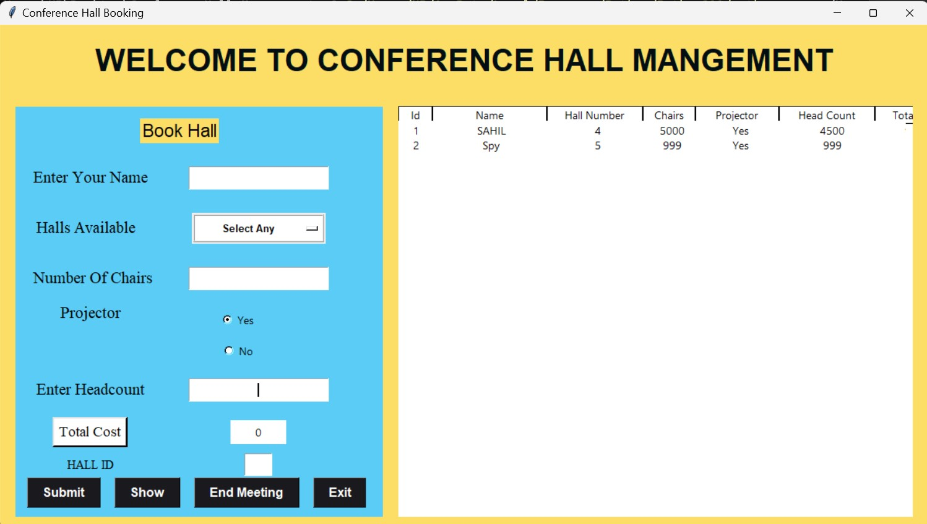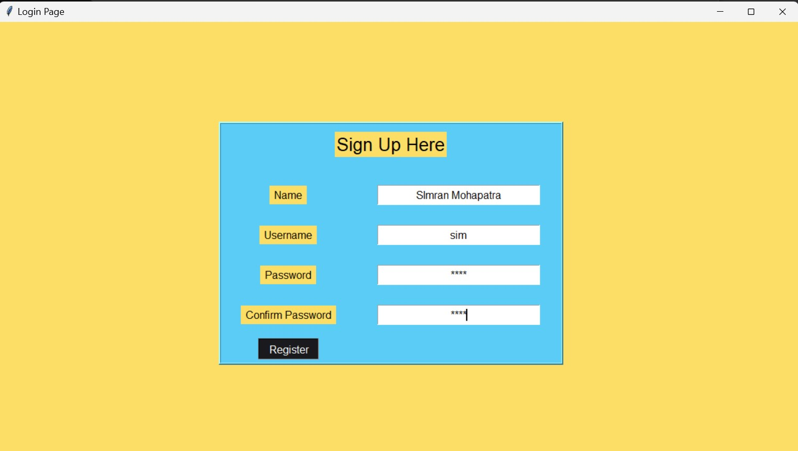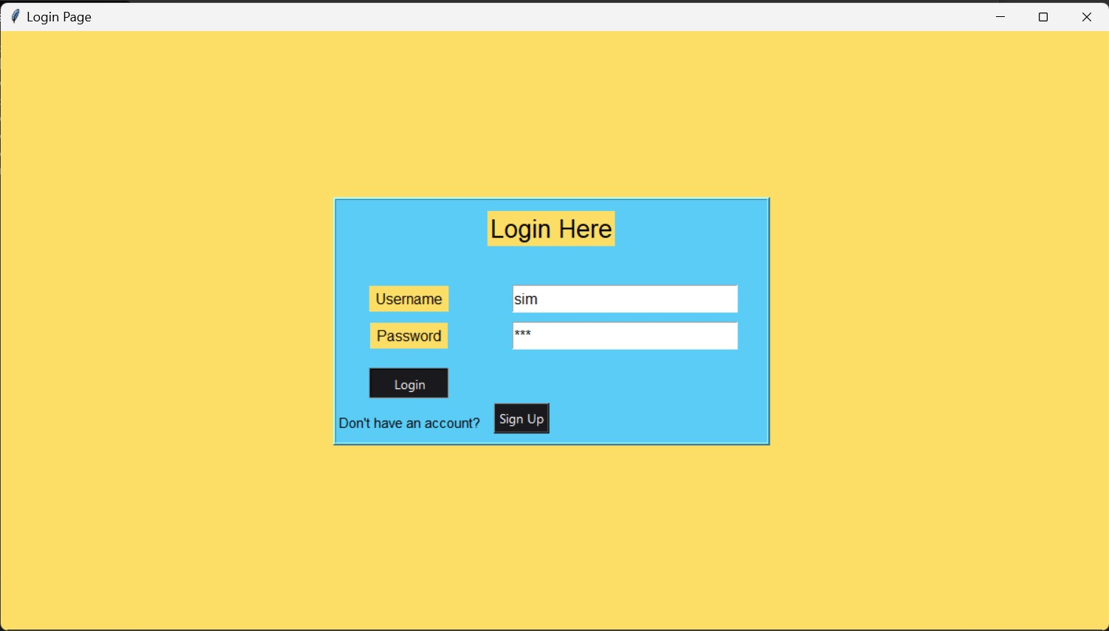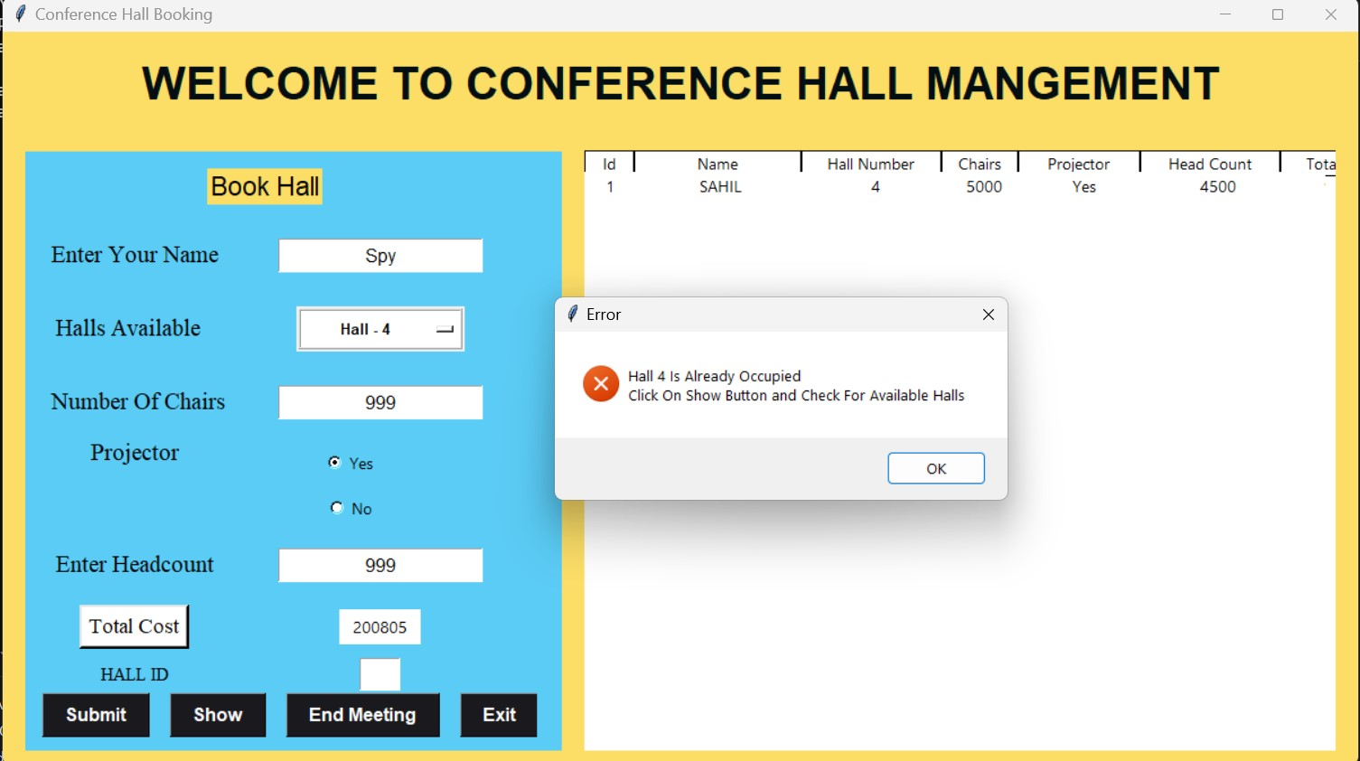

1. **Question: What does the code do?**

**Answer:** The code is a simple Python script that creates a GUI for a login system using **Tkinter**. It includes functionalities for user login and signup, and it uses SQLite to store and manage user data.

1. **Question: Explain the purpose of the CREATE TABLE statement.**

**Answer:** The **CREATE TABLE** statement is used to define a new table named **registered_users** in the SQLite database. This table is intended to store information about registered users, including their name, username, and password.

1. **Question: Why is there a try-except block around the table creation code?**

**Answer:** The try-except block is used to handle exceptions that may occur during the execution of the **CREATE TABLE** statement. If the table already exists, an exception will be raised, and the code in the except block will print the error. This is helpful for avoiding errors when running the script multiple times.

1. **Question: What is the purpose of the DELETE FROM registered_users statement?**

**Answer:** This statement is commented out, but if uncommented, it would delete all records from the **registered_users** table. It can be useful for clearing the table during development or testing, but it should be used with caution in a production environment.

1. **Question: How does the login function work?**

**Answer:** The login function checks whether the entered username and password match a record in the **registered_users** table. If a match is found, it displays a welcome message. If no user is found or the password is incorrect, appropriate error messages are displayed.

1. **Question: Explain the purpose of the signup function.**

**Answer:** The signup function is called when the user clicks the "Sign Up" button. It switches the GUI to a signup frame where the user can enter their name, username, password, and confirm the password. The entered information is then validated, and if successful, a new record is inserted into the **registered_users** table.

1. **Question: Why is there a nested function register within the signup function?**

**Answer:** The nested function **register** is responsible for validating and inserting user information into the database. It ensures that all required fields are filled, passwords match, and the chosen username is unique. This organization helps keep the code modular and readable.

1. **Question: How is data stored in the SQLite database?**

**Answer:** Data is stored in the **registered_users** table, where each record represents a registered user. The fields include **NAME**, **USERNAME**, and **PASSWORD**. The SQLite database file is named **conferenceHall.db**.

1. **Question: Why is SQLite used for storing user data in this code?**

**Answer:** SQLite is a lightweight, embedded database that is well-suited for small to medium-sized applications. It provides a simple way to store and retrieve structured data, making it suitable for applications like this one where a full-scale database management system might be unnecessary.

1. **Question: How does the code handle exceptions during database operations?**

**Answer:** The code uses try-except blocks to handle exceptions that may occur during database operations. For example, if there is an issue with creating the table, the exception is caught and the error message is printed. This approach helps in identifying and addressing potential issues during development.

1. **Question: Explain the significance of the root object in the code.**

**Answer:** The **root** object is the main window of the Tkinter GUI. It is created using the **Tk()** constructor and serves as the parent window for all other GUI elements. The **mainloop()** method is called on the **root** object to start the event handling loop, allowing the GUI to respond to user actions.

1. **Question: How does the code ensure that passwords are secure?**

**Answer:** The code does not explicitly implement advanced security measures like hashing or salting of passwords. For enhanced security, it is recommended to implement password hashing techniques to store passwords securely. This code serves as a basic example and should not be used in a production environment without additional security enhancements.

1. **Question: Describe the purpose of the place_forget() method in the code.**

**Answer:** The **place_forget()** method is used to remove a widget from its parent widget, effectively hiding it from the GUI. In the code, it is employed when switching between the login and signup frames. This approach allows for a clean transition between different sections of the GUI.

1. **Question: How does the code handle potential SQL injection vulnerabilities?**

**Answer:** The code uses parameterized queries when interacting with the SQLite database, which helps mitigate SQL injection risks. Parameters are placeholders for values, and they are substituted into the query in a way that prevents malicious manipulation of the SQL statements.

1. **Question: Can you explain the purpose of the linktr.ee URL in the provided user profile?**

**Answer:** The **linktr.ee** URL in the user profile is a Linktree link. Linktree is a tool that allows users to create a landing page with multiple links to various online profiles or resources. In this case, it might contain links to the user's GitHub, Twitter, Instagram, and other social media profiles.

1. **Question: What is the purpose of the maxsize and minsize methods applied to the root window?**

**Answer:** The **maxsize** and **minsize** methods set the maximum and minimum dimensions for the Tkinter window (**root** in this case). These methods restrict the user from resizing the window beyond the specified dimensions, ensuring a consistent and controlled user interface.

1. **Question: Explain the role of the messagebox module in the code.**

**Answer:** The **messagebox** module is used to create popup message boxes for displaying errors, information, or warnings to the user. In the code, it is primarily used to show error messages when certain conditions are not met during login or signup attempts.

1. **Question: How does the code handle the event when the user closes the Tkinter window?**

**Answer:** The code uses the **root.mainloop()** method to start the Tkinter event handling loop. This loop continues until the user closes the window, at which point it exits, effectively terminating the program.

1. **Question: Can you explain the purpose of the bd parameter in the Button widget?**

**Answer:** The **bd** parameter in the **Button** widget stands for "border." It is used to specify the width of the button's border. In the code, the **login_btn** and **sign_up** buttons both have a border width of 2.

1. **Question: How is the Linktree link in the user profile relevant to the code?**

**Answer:** The **Linktree** link provides a centralized location for the user's various online profiles. While not directly related to the code, it can be a convenient way for users to share multiple links, such as social media profiles and project repositories, with others.

1. **Question: What happens when the user clicks the "Sign Up" button?**

**Answer:** Clicking the "Sign Up" button triggers the **signup** function, which switches the GUI to a signup frame. This frame allows users to enter their registration information. The **register** function within handles the registration process when the "Register" button is clicked.

1. **Question: How could you enhance the code to improve security, especially regarding password handling?**

**Answer:** To enhance security, passwords should be hashed before storing them in the database. Additionally, implementing salting techniques can further fortify the password storage mechanism. The code should be modified to incorporate these security best practices.

1. **Question: Explain the significance of the Label widget with the text "Don't have an account?" in the login frame.**

**Answer:** This **Label** serves as a visual prompt to encourage users to sign up if they don't have an existing account. It provides a clear call-to-action for users who may be new to the system.

1. **Question: How can you make the code more modular and maintainable?**

**Answer:** The code can be modularized by separating different functionalities into functions or classes. For example, the login and signup logic could be encapsulated in separate functions or classes, making the code more organized and easier to maintain.

1. **Question: What potential issues or limitations do you see in the current code?**

**Answer:** The code lacks proper password security measures like hashing, making it susceptible to security vulnerabilities. Additionally, error handling could be more comprehensive, and the GUI layout and design could be improved for a better user experience.